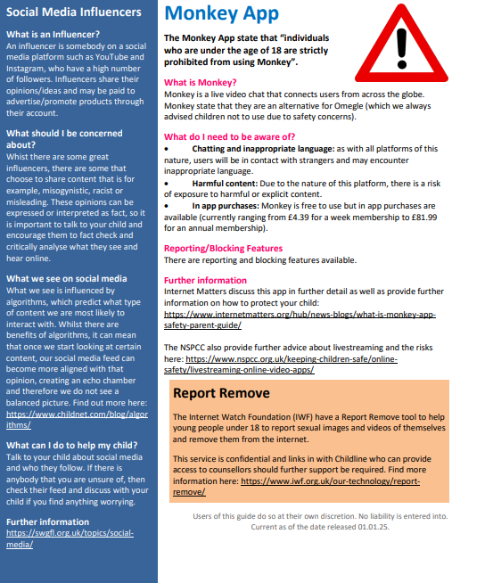


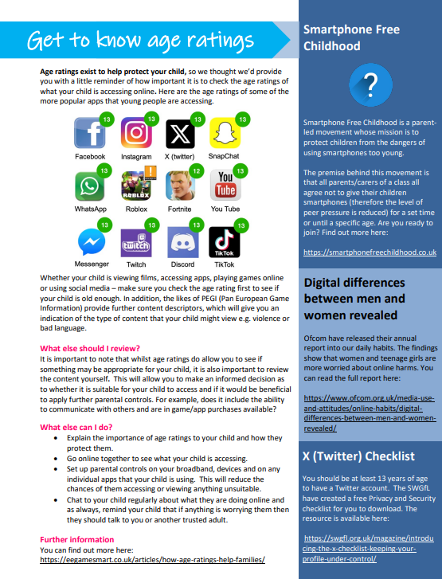
SPRING NEWSLETTER- THOMAS TELFORD SCHOOL

